**Data Mining – Assignment 2**

**1930026143 薛劭杰**

Q1.

For {e}:

$Support count σ\left(\left\{e\right\}\right)=4$

$Support s(\{e\})=\frac{σ}{\left|T\right|}=\frac{4}{5}$, where $\left|T\right|=5$ is the number of transactions.

For {b, d}

$Support count σ\left(\{b, d\}\right)=3$

$Support s=\frac{σ}{\left|T\right|}=\frac{3}{5}$, where $\left|T\right|=5$ is the number of transactions.

For {b, d, e}

$Support count σ\left(\{b, d\}\right)=2$

$Support s=\frac{σ}{\left|T\right|}=\frac{2}{5}$, where $\left|T\right|=5$ is the number of transactions.

(i). $C_{1}: \left\{a\right\},\left\{b\right\},\left\{c\right\},\left\{d\right\}, \{e\}$

|  |  |
| --- | --- |
| Item | Support |
| $$\{a\}$$ | 5 |
| $$\{b\}$$ | 3 |
| $$\{c\}$$ | 4 |
| $$\{d\}$$ | 5 |
| $$\{e\}$$ | 4 |

For $\{b\}$: $\frac{3}{5}<80\%$, so it should be pruned.

$C_{2}: \left\{a, c\right\}, \left\{a, d\right\}, \left\{a, e\right\}, \left\{c,d\right\},\left\{c, e\right\}, \{d, e\}$

|  |  |
| --- | --- |
| Item | Support |
| $$\left\{a, c\right\}$$ | 4 |
| $$\left\{a, d\right\}$$ | 5 |
| $$\left\{a, e\right\}$$ | 4 |
| $$\left\{c,d\right\}$$ | 4 |
| $$\left\{c, e\right\}$$ | 3 |
| $$\{d, e\}$$ | 4 |

For $\{c, e\}$: $\frac{3}{5}<80\%$, so it should be pruned.

$C_{3}: \left\{a,c,d\right\},\left\{a,d,e\right\},\{c,d,e\}$

|  |  |
| --- | --- |
| Item | Support |
| $$\left\{a,c,d\right\}$$ | 4 |
| $$\left\{a,d,e\right\}$$ | 4 |
| $$\{c,d,e\}$$ | 3 |

For $\{c,d, e\}$: $\frac{3}{5}<80\%$, so it should be pruned.

$C_{4}: nothing$

|  |  |
| --- | --- |
| Item | Support |
|  |  |

(ii).

|  |  |
| --- | --- |
| Item | Count |
| {a} | 5 |
| {c} | 4 |
| {d} | 4 |
| {e} | 4 |

|  |  |
| --- | --- |
| Item | Count |
| {a, c} | 4 |
| {a, d} | 5 |
| {a, e} | 4 |
| {c, d} | 4 |
| {d, e} | 4 |

|  |  |
| --- | --- |
| Item | Count |
| {a, c, d} | 4 |
| {a, d, e} | 4 |

|  |  |
| --- | --- |
| Item | Count |
|  |  |

(c).

$confidence c\left(\left\{a\}→\{c\right\}\right)=P\left(c | a\right)=\frac{4}{5}$ $confidence c\left(\left\{c\}→\{a\right\}\right)=P\left(a | c\right)=\frac{4}{4}=1$ $confidence c\left(\left\{a\}→\{d\right\}\right)=P\left(d | a\right)=\frac{5}{5}=1 confidence c\left(\left\{d\}→\{a\right\}\right)=P\left(a | d\right)=\frac{5}{5}=1$

$confidence c\left(\left\{a\}→\{e\right\}\right)=P\left(e | a\right)=\frac{4}{5}$ $confidence c\left(\left\{c\}→\{a\right\}\right)=P\left(a | e\right)=\frac{4}{4}=1$

$confidence c\left(\left\{c\}→\{d\right\}\right)=P\left(d | c\right)=\frac{4}{4}=1$ $confidence c\left(\left\{d\}→\{c\right\}\right)=P\left(c | d\right)=\frac{4}{5}$

$confidence c\left(\left\{d\}→\{e\right\}\right)=P\left(e | d\right)=\frac{4}{5}$ $confidence c\left(\left\{e\}→\{d\right\}\right)=P\left(d | e\right)=\frac{4}{4}=1$

$confidence c\left(\left\{a\}→\{c,d\right\}\right)=P\left(c,d | a\right)=\frac{4}{5}$ $confidence c\left(\left\{c,d\}→\{a\right\}\right)=\left(a | c,d\right)=\frac{4}{4}=1$

$confidence c\left(\left\{c\}→\{a,d\right\}\right)=P\left(a,d | c\right)=\frac{4}{4}=1$ $confidence c\left(\left\{a,d\}→\{c\right\}\right)=\left(c | a,d\right)=\frac{4}{5}$

$confidence c\left(\left\{d\}→\{a,c\right\}\right)=P\left(a,c | d\right)=\frac{4}{5}$ $confidence c\left(\left\{a,c\}→\{d\right\}\right)=\left(d | a,c\right)=\frac{4}{4}=1$

$confidence c\left(\left\{a\}→\{d,e\right\}\right)=P\left(d,e | a\right)=\frac{4}{5}$ $confidence c\left(\left\{d,e\}→\{a\right\}\right)=\left(a | d,e\right)=\frac{4}{4}=1$

$confidence c\left(\left\{d\}→\{a,e\right\}\right)=P\left(a,e | d\right)=\frac{4}{5}$ $confidence c\left(\left\{a,e\}→\{d\right\}\right)=\left(d | a,e\right)=\frac{4}{4}=1$

$confidence c\left(\left\{e\}→\{a,d\right\}\right)=P\left(a,d | e\right)=\frac{4}{4}=$ 1 $confidence c\left(\left\{a,d\}→\{e\right\}\right)=\left(e | a,d\right)=\frac{4}{5}$

$So$ the list of strong rules are:

$\left\{c\right\}→\left\{a\right\}, \left\{a\}→\{d\right\}, \left\{d\}→\{a\right\},\left\{c\}→\{a\right\}, \left\{c\}→\{d\right\},\left\{e\}→\{d\right\}, \left\{c,d\}→\{a\right\},\left\{c\right\}→\left\{a,d\right\}, \left\{a,c\}→\{d\right\}, \left\{d,e\}→\{a\right\}, \left\{a,e\}→\{d\right\}, \left\{e\right\}→\{a,d\}$

(d).

At the beginning, we should modify the database by removing the infrequent items. According to the (b) in this question, $\left\{b\right\}$ is infrequent so it should be removed. Then sort the remaining items in every transaction according to the count order.

|  |  |
| --- | --- |
| Transaction ID | Items Bought |
| T1 | $$\left\{a,d,c,e\right\}$$ |
| T2 | $$\left\{a,d,c,e\right\}$$ |
| T3 | $$\left\{a,d,c,e\right\}$$ |
| T4 | $$\left\{a,d,c\right\}$$ |
| T5 | $$\left\{a,d,e\right\}$$ |

Create a branch from the root and insert T1:

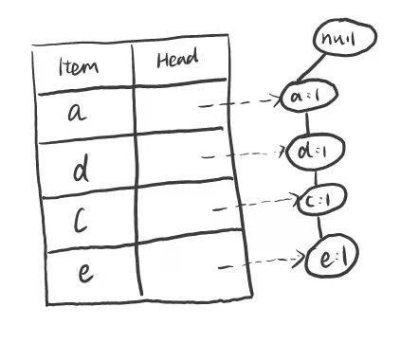

Insert T2:

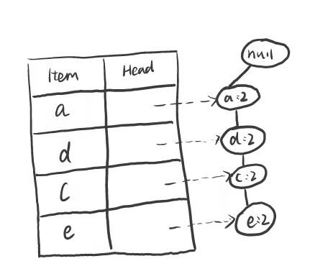

Insert T3:

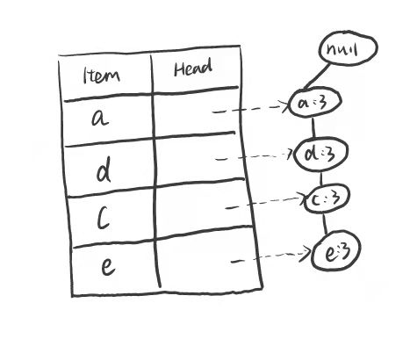

Insert T4:

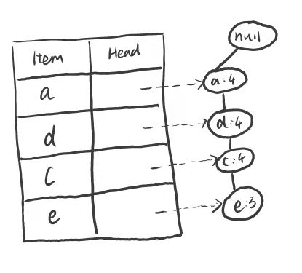

Insert T5:

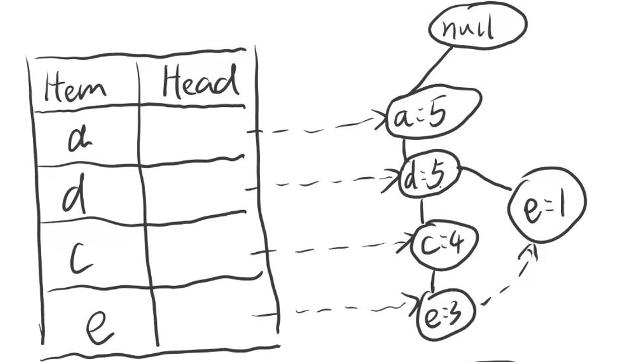



Generate pattern {e}:

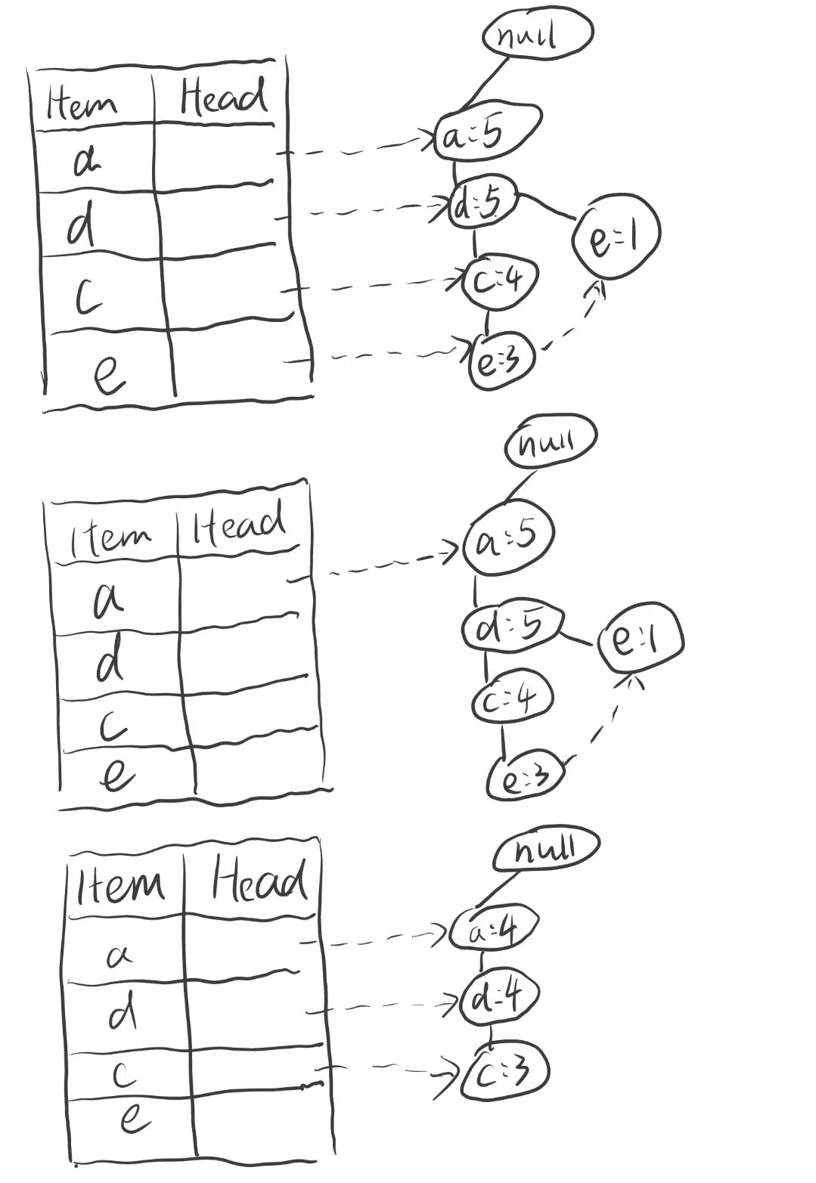

Generate pattern {c}:

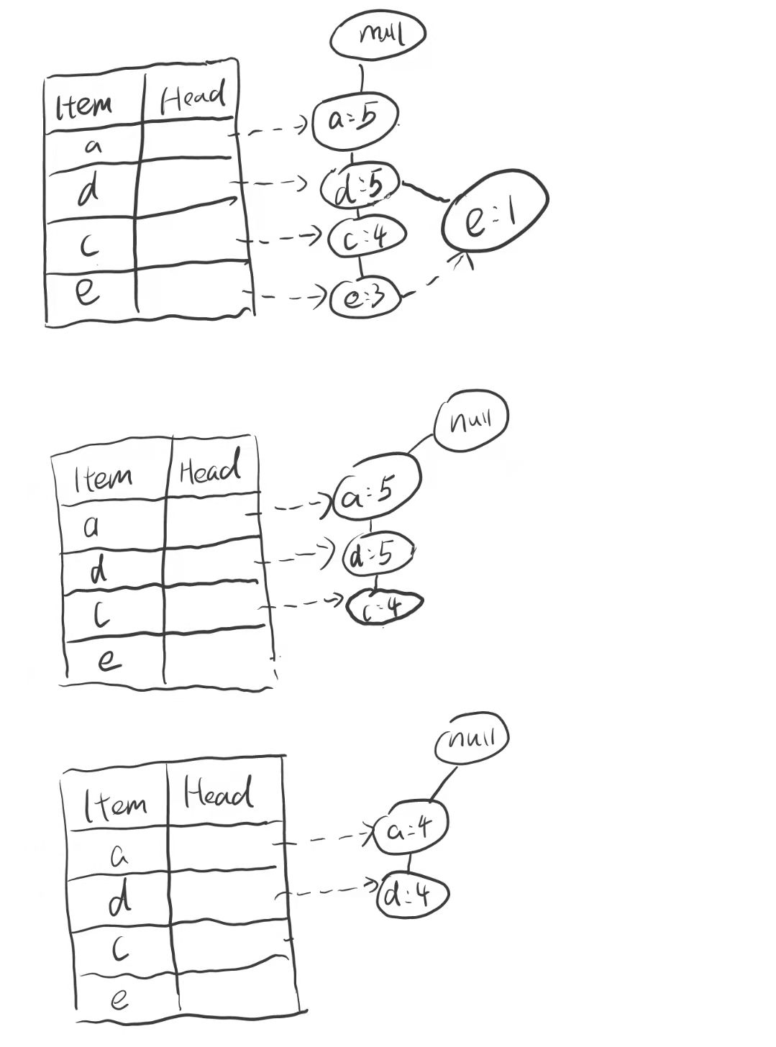

Generate pattern {d}:

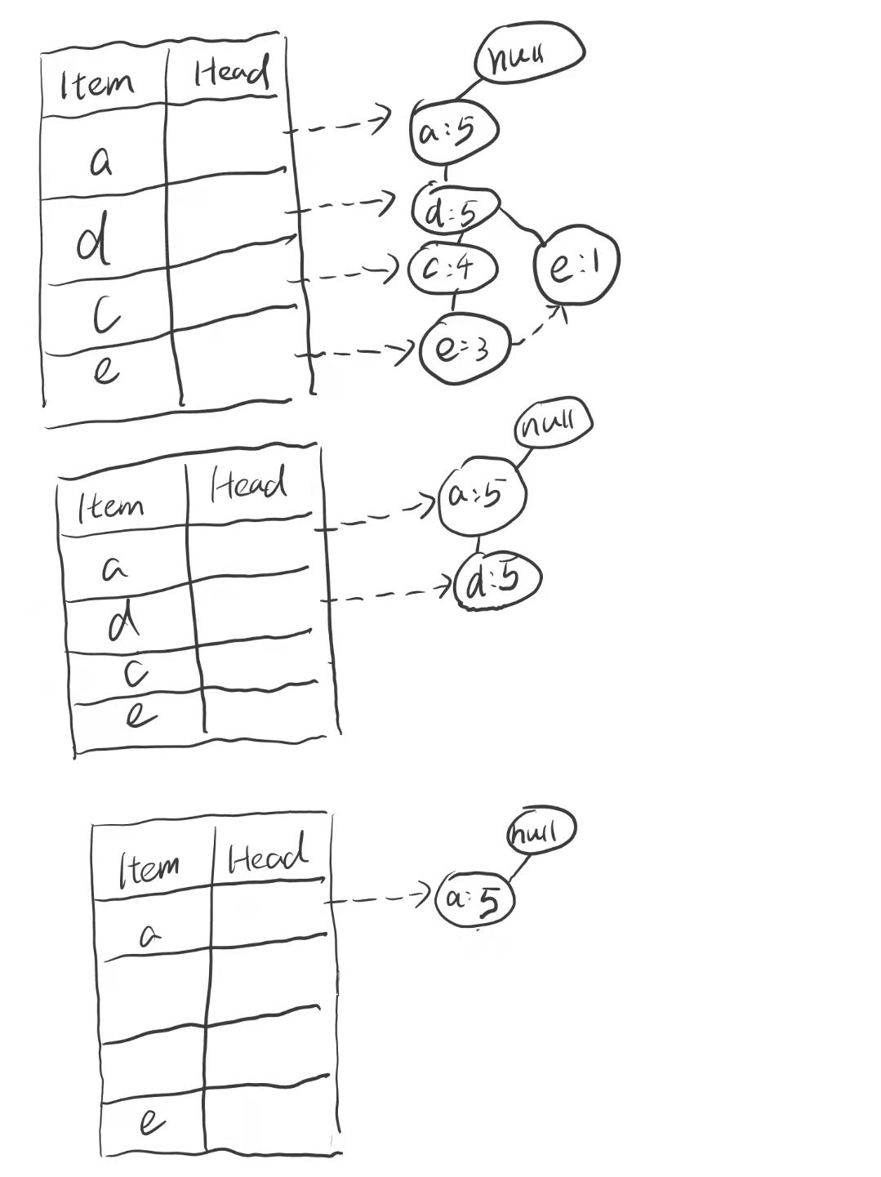

Generate pattern {a}:

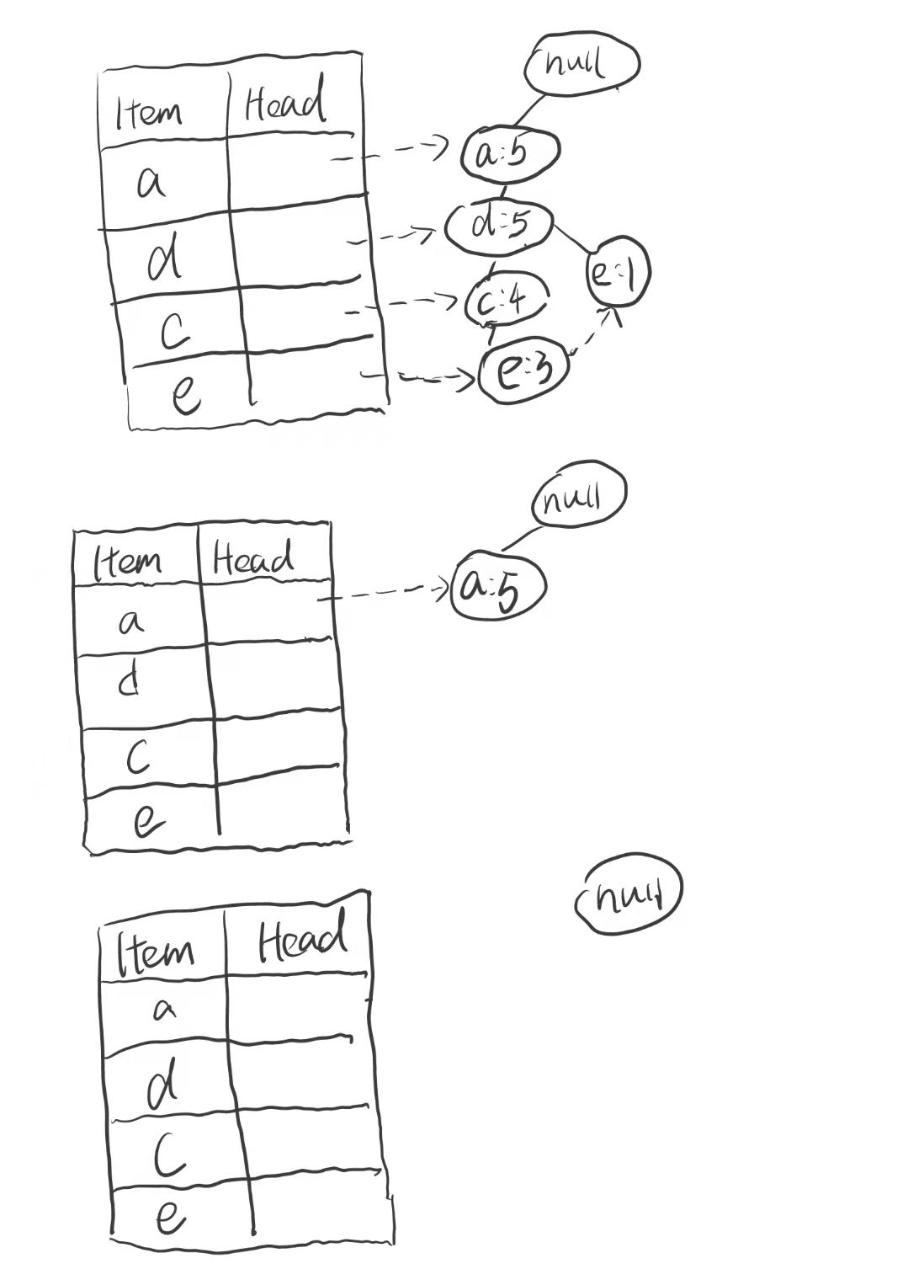

Q2.

$I\left(D\right)=-\frac{4}{6}*\log_{2}{\frac{4}{6}}-\frac{2}{6}*\log_{2}{\frac{2}{6}}≈0.9183$

For chest pain:

$I\left(D_{yes}\right)=-1*\log_{2}{1}-0*\log_{2}{0}=0$

$I\left(D_{no}\right)=-\frac{2}{3}*\log_{2}{\frac{2}{3}}-\frac{1}{3}*\log_{2}{\frac{1}{3}}=0.9183$

$Weighted Average(Pain)=\frac{3}{6}*0+\frac{3}{6}*0.9182=0.4591$

$Gain\left(D, Chest Pain\right)=0.9183-0.4591=0.4592$

For male:

$I\left(D_{yes}\right)=-\frac{2}{4}*\log_{2}{\frac{2}{4}}-\frac{2}{4}*\log_{2}{\frac{2}{4}}=1$

$I\left(D_{no}\right)=-1*\log_{2}{1}-0*\log_{2}{0}=0$

$Weighted Average(Male)=\frac{4}{6}*1+\frac{2}{6}*0≈0.6667$

$Gain\left(D, Chest Pain\right)=0.9183-0.6667=0.2516$

For smoke:

$I\left(D_{yes}\right)=-\frac{1}{4}*\log_{2}{\frac{1}{4}}-\frac{3}{4}*\log_{2}{\frac{3}{4}}≈0.8113$

$I\left(D_{no}\right)=-\frac{1}{2}*\log_{2}{\frac{1}{2}}-\frac{1}{2}*\log_{2}{\frac{1}{2}}=1$

$Weighted Average(Smoke)=\frac{4}{6}*0.8113+\frac{2}{6}*1≈0.8742$

$Gain\left(D, Chest Pain\right)=0.9183-0.8742=0.0441$

For exercise:

$I\left(D_{yes}\right)=-\frac{2}{4}*\log_{2}{\frac{2}{4}}-\frac{2}{4}*\log_{2}{\frac{2}{4}}=1$

$I\left(D_{no}\right)=-1*\log_{2}{1}-0*\log_{2}{0}=0$

$Weighted Average(Exercise)=\frac{4}{6}*1+\frac{2}{6}*0≈0.6667$

$Gain\left(D, Chest Pain\right)=0.9183-0.6667=0.2516$

$Gain\left(D, Chest Pain,\right)>Gain\left(D,Male\right)≥Gain\left(D,Exercise\right)>Gain(D,Smoke)$

Split using attribute chest pain.

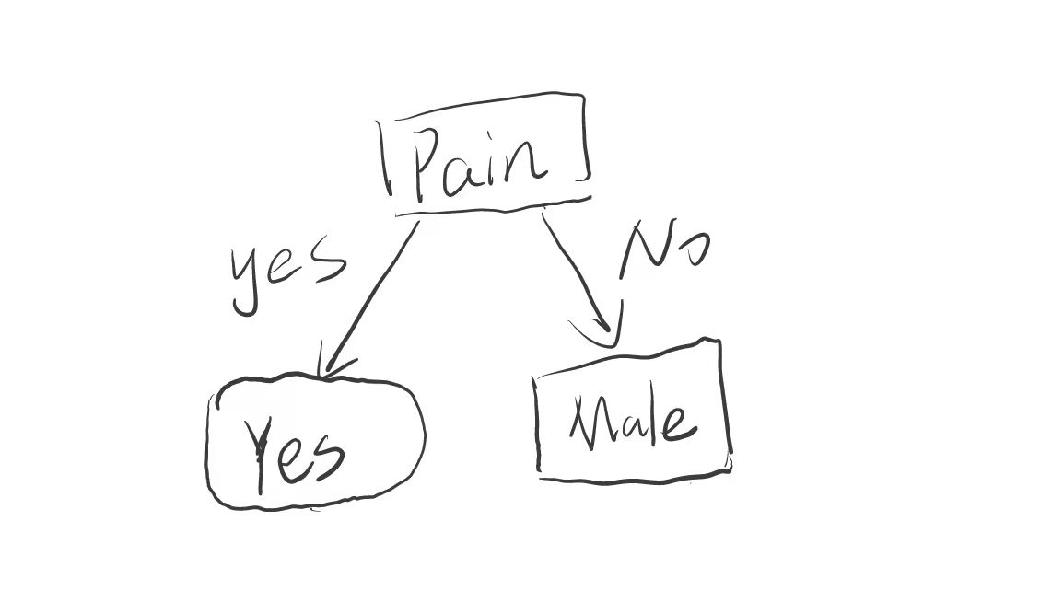

Then for the rest of item:

$I\left(D\right)=-\frac{2}{3}*\log_{2}{\frac{2}{3}}-\frac{1}{3}*\log_{2}{\frac{1}{3}}≈0.9183$

For male:

$I\left(D_{yes}\right)=-1*\log_{2}{1}-0*\log_{2}{0}=0$

$I\left(D_{no}\right)=-1*\log_{2}{1}-0*\log_{2}{0}=0$

$Weighted Average\left(Male\right)=\frac{2}{3}*0+\frac{1}{3}*0=0$

$Gain\left(D, Chest Pain\right)=0.9183-0=0.9183$

For smoke:

$I\left(D_{yes}\right)=-\frac{1}{2}*\log_{2}{\frac{1}{2}}-\frac{1}{2}*\log_{2}{\frac{1}{2}}=1$

$I\left(D_{no}\right)=-1*\log_{2}{1}-0*\log_{2}{0}=0$

$Weighted Average(Smoke)=\frac{2}{3}*1+\frac{1}{3}*0≈0.6667$

$Gain\left(D, Chest Pain\right)=0.9183-0.6667=0.2516$

For exercise:

$I\left(D_{yes}\right)=-1*\log_{2}{1}-0*\log_{2}{0}=0$

$I\left(D_{no}\right)=-1*\log_{2}{1}-0*\log_{2}{0}=0$

$Weighted Average\left(Exercise\right)=\frac{2}{3}*0+\frac{1}{3}*0=0$

$Gain\left(D, Chest Pain\right)=0.9183-0=0.9183$

$Gain\left(D,Male\right)≥Gain\left(D,Exercise\right)>Gain(D,Smoke)$

Split using attribute male.

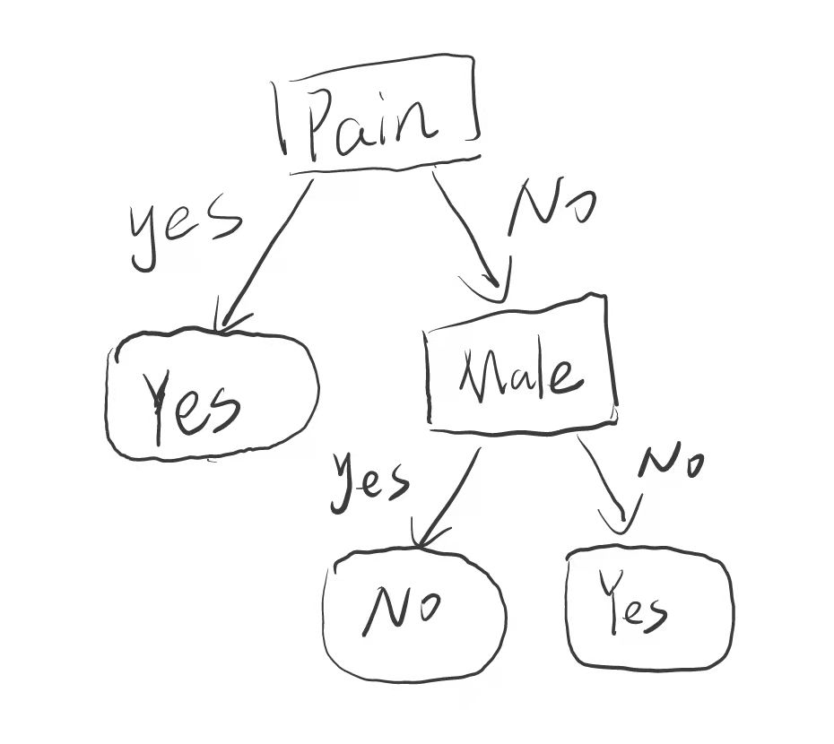

(b).

According to the (a) decision,

|  |  |
| --- | --- |
| Predicted | Actual |
| Yes | No |
| Yes | Yes |
| Yes | Yes |
| No | No |
| No | Yes |
| Yes | No |

|  |  |  |
| --- | --- | --- |
| Classes | C1 | C2 |
| C1 | 2 (TP) | 1 (FN) |
| C2 | 2 (FP) | 1 (TN) |

$Precision=\frac{TP}{TP+FP}=\frac{2}{4}=\frac{1}{2}$

$Recall=\frac{TP}{TP+FN}=\frac{2}{3}$

$F1$- $Score=\frac{TP}{TP+FP}=2*\frac{Precision*Recall}{Precision+Recall}=2*\frac{\frac{1}{2}*\frac{2}{3}}{\frac{1}{2}+\frac{2}{3}}=\frac{4}{7}$

Q3.

$C1=Heart Attack \left(Yes\right), C2=Heart Attack (No)$

$P\left(C_{1}\right)=\frac{4}{6}≈0.6667, P\left(C_{2}\right)=\frac{2}{6}≈0.3333$

For Patient 7:

$P\left( Chest Pain=Yes\right|C_{1})=\frac{3+1}{4+2}≈0.6667,P\left( Chest Pain=Yes\right|C_{2})=\frac{0+1}{2+2}=\frac{1}{4}=0.25$

$P\left( Male=Yes\right|C_{1})=\frac{2+1}{4+2}=0.5,P\left( Male=Yes\right|C_{2})=\frac{2+1}{2+2}=0.75$

$P\left(Smoke=No\right|C_{1})=\frac{1+1}{4+2}≈0.3333,P\left(Smoke=No\right|C_{2})=\frac{1+1}{2+2}=0.5$

$P\left(Exercise=Yes\right|C_{1})=\frac{2+1}{4+2}=0.5,P\left(Exercise=Yes\right|C_{2})=\frac{2+1}{2+2}=0.75$

$P\left(x | C_{1}\right)=P\left( Chest Pain=Yes\right|C_{1})*P\left( Male=Yes\right|C_{1})*P\left(Smoke=No\right|C_{1})*P\left(Exercise=Yes\right|C_{1})=0.6667*0.5*0.3333*0.5≈0.0556$

$P\left(x | C_{2}\right)=P\left( Chest Pain=Yes\right|C_{2})*P\left( Male=Yes\right|C_{2})*P\left(Smoke=No\right|C_{2}) *P\left(Exercise=Yes\right|C_{2})=0.25*0.75*0.5*0.75=0.0703125$

$P\left(x | C_{1}\right)*P\left(C_{1}\right)=0.0556*0.6667≈0.03707$

$P\left(x | C_{2}\right)*P\left(C_{2}\right)=0.0703125*0.3333≈0.02344$

Because $0.03707>0.02344$, the patient 7 may have heart attack.

For Patient 8:

$P\left( Chest Pain=Yes\right|C_{1})=\frac{3+1}{4+2}=0.6667,P\left( Chest Pain=Yes\right|C_{2})=\frac{0+1}{2+2}=\frac{1}{4}=0.25$

$P\left( Male=No\right|C_{1})=\frac{2+1}{4+2}=0.5, P\left( Male=No\right|C_{2})=\frac{0+1}{2+2}=0.25$

$P\left(Smoke=Yes\right|C_{1})=\frac{3+1}{4+2}=0.6667, P\left(Smoke=Yes\right|C_{2})=\frac{1+1}{2+2}≈0.5$

$P\left(Exercise=No\right|C_{1})=\frac{2+1}{4+2}=0.5,P\left(Exercise=No\right|C_{2})=\frac{0+1}{2+2}=0.25$

$P\left(x | C_{1}\right)=P\left( Chest Pain=Yes\right|C_{1})*P\left( Male=No\right|C_{1})*P\left(Smoke=Yes\right|C_{1})*P\left(Exercise=No\right|C_{1})=0.6667*0.5*0.6667*0.5≈0.1111$

$P\left(x | C_{2}\right)=P\left( Chest Pain=Yes\right|C_{2})*P\left( Male=No\right|C_{2})*P\left(Smoke=Yes\right|C_{2})*P\left(Exercise=No\right|C_{2})=0.25*0.25*0.5*0.25=0.0078125$

$P\left(x | C_{1}\right)*P\left(C_{1}\right)=0.1111*0.6667=0.07407$

$P\left(x | C_{2}\right)*P\left(C_{2}\right)=0.0078125*0.3333=0.002604$

Because $0.07407 >0.02604$, the patient 8 may have heart attack.